EDG-2A Operator’s Handbook

Contents
Introduction - 3 -
1.1 Features - 3 -
1.2 Packing List - 3 -
1.3 Charging the Battery - 4 -
Operation of the EDG - 4 -
2.1Power on/off - 4 -
2.2 EDG MAIN - 4 -
2.3 Model - 5 -
2.3.1 New Model - 6 -
2.3.2 Model Settings - 9 -
2.3.3 Normal Fix - 10 -
2.3.4 One Point Fix - 10 -
2.3.5 Delete a model - 11 -
2.4 Project - 11 -
2.4.1 New Project - 12 -
2.4.2 Associate with a model - 13 -
2.4.3 Start Test - 14 -
2.4.4 Result View - 16 -
2.4.5 Delete test points of a project - 17 -
2.4.6 Export the data - 17 -
2.4.7 Delete a project - 17 -
2.5 GPS Control - 17 -
2.6 Data share - 18 -
2.7 System Settings - 19 -
Notice(Routine Operations) - 20 -
Watch for suspicious readings - 20 -

Introduction

1.1 Features
Asphalt pavement electronic density gauge (abbreviated as EDG) utilizes advanced electromagnetic technology to obtain accurate soil density readings.
Primary features:
※ No radioactive materials or special license required
※ Light weight and easy to use
※ Without compromising the integrity of the sample structure
※ Measures density in common units (kg/m³)
※ Measures for the temperature of the asphalt pavement
※ Stores 40000 readings on internal Data Logger
※ Optional download to computer
※ GPS, WIFI and 4G inside
How does it work?
The density of soil is directly proportional to the measured dielectric constant of the material. EDG uses electrical waves to measure dielectric constant using an innovative, toroidal electrical sensing field established by the sensing plate.
The electronics in the EDG convert the field signals into material density readings and displays the results. Once calibrated, direct density readings can be consistently obtained.
As shown below:
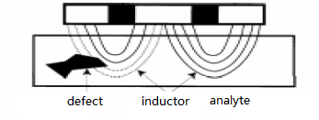

1.2 Packing List
The EDG shipment package includes the items listed below. Please contact your dealer if any part missing.
- Instrument box
- One EDG unit
- One battery charger
- USB A-C cable
- User manual, warranty card and certificate

1.3 Charging the Battery
Note: Be sure to use the original charger for charging.
EDG is powered by lithium batteries which weigh less and smaller.
Under normal operation, EDG can operate in excess of 15 hours at full charge. The internal 3.7 volt battery is designed to be recharged in approximately 8 hours, using the charger with 5V output.
Warning！
Attempting to recharge the unit in any other way than with the recharger supplied with the unit can result in damage to the unit and can present a safety hazard. Use of any charging means other than the recharger supplied with the unit will void the unit's warranty.

Operation of the EDG
Starting EDG for the first time. Turn EDG on by flipping the POWER switch on the left. The internal buzzer emits a beep sound. Then the unit begins self-test and starts. After a few seconds the display will show the MAIN menu.

2.1Power on/off
When the device is turned off, press the power button for 0.5 seconds and then release it. The instrument will start up for self-check and display the startup screen. Wait for a few seconds and then enter the MAIN MENU.
When the device is turned on, press and hold the power button for 4 seconds. The green working indicator light will remain on constantly. At this point, release the power button and the instrument will be turned off.

2.2 EDG MAIN
After boot up, the screen displays as follows:
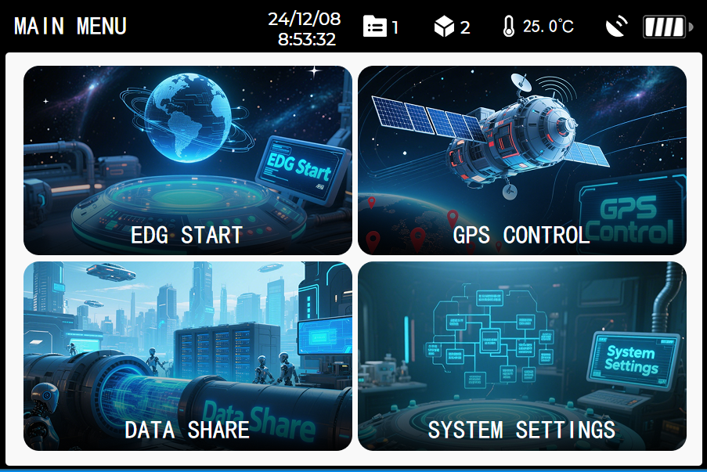
Information
Battery Level
GPS State
Project Number
Model Number
Current Menu
The current menu interface, storage and status information are displayed at the top of the screen. When the EDG is located outdoors, the GPS status indicator icon is displayed. Otherwise, it is not displayed.

2.3 Model
In the MAIN MENU, click the button "EDG START", the screen displays as follows:
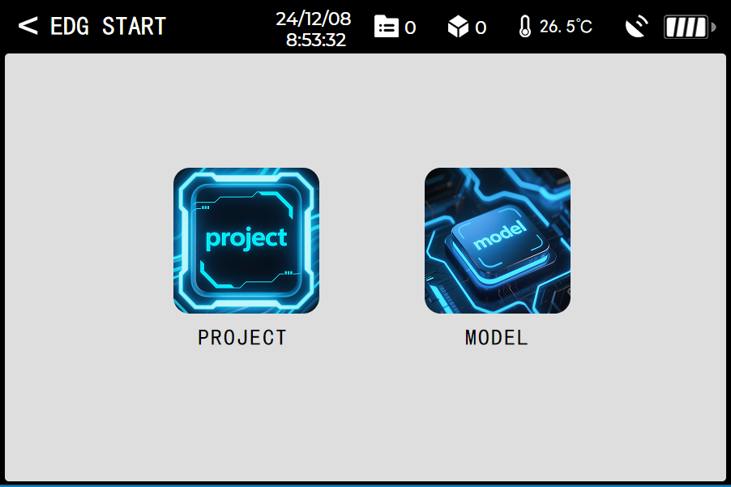
Back
In the EDG START menu, click the button “MODEL”, turn to the MODEL menu:
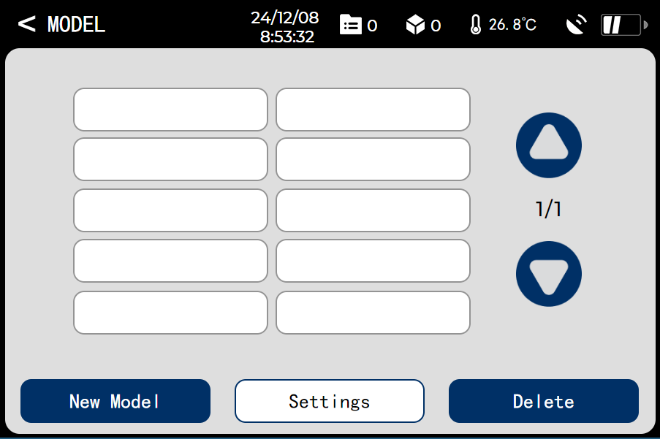

2.3.1 New Model
Click the button "New Model" and input a name:
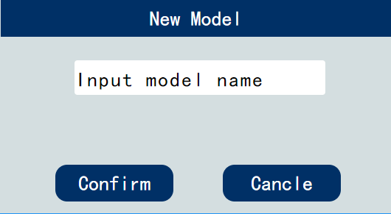
Click the button “Confirm” to enter the menu ”CALIBRATION”. In this menu, you should read the sensor data of two different test points to calibrate the model. This method is named as “two points calibration”.

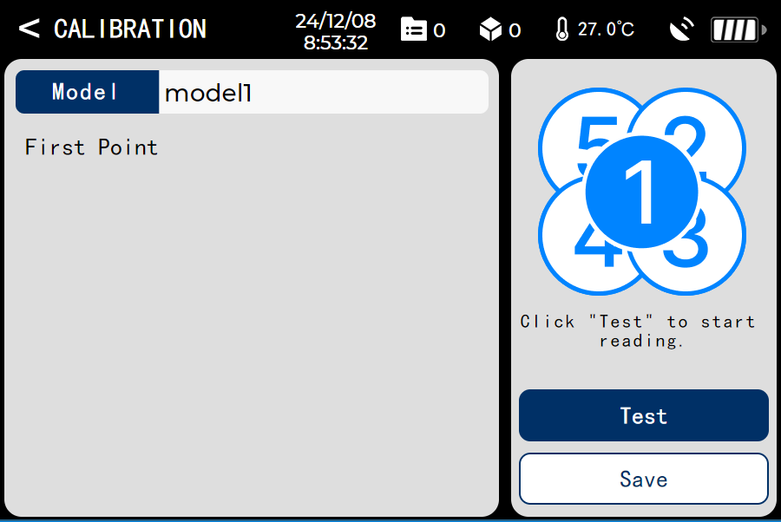
First, you should select one point and place the EDG at the sampling position. Note: Ensure good contact between the sensor and the asphalt pavement. Obtain readings at the positions as shown below.

Draw a circle around the sensor's outer edge of EDG and take readings in the center (1) and at 2 o'clock, 5 o'clock, 8 o'clock and 11 o'clock positions. After reading number 5 is complete, the data of the 5 readings will be saved.
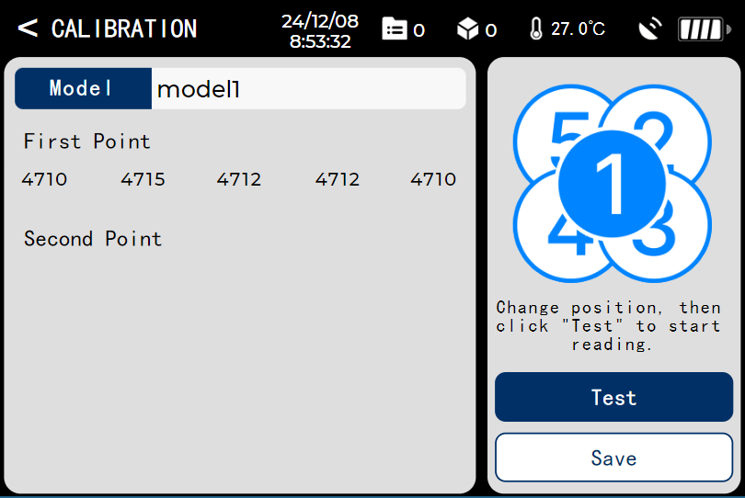
After reading the data of the first point, you should take a sample of the core from the first point to obtain its density. Change the location, then reading the data of the second point.
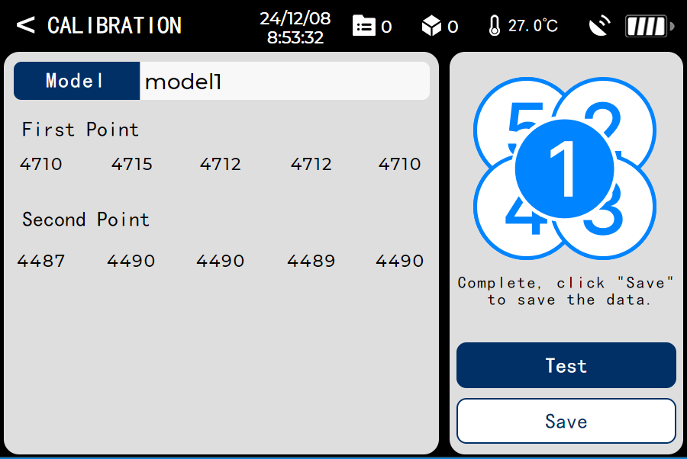
After reading complete, click “Save” to save the data. You should take a sample of the core from the second point to obtain its density.

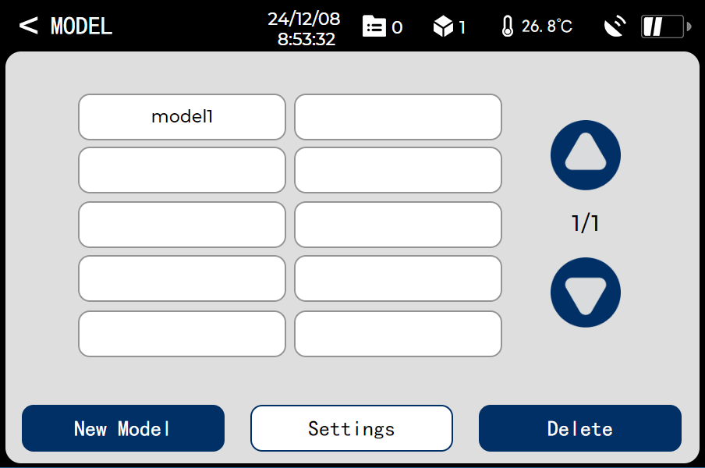

2.3.2 Model Settings
In the MODEL menu, you can set the parameter of a model which is selected by clicking the button "Settings".
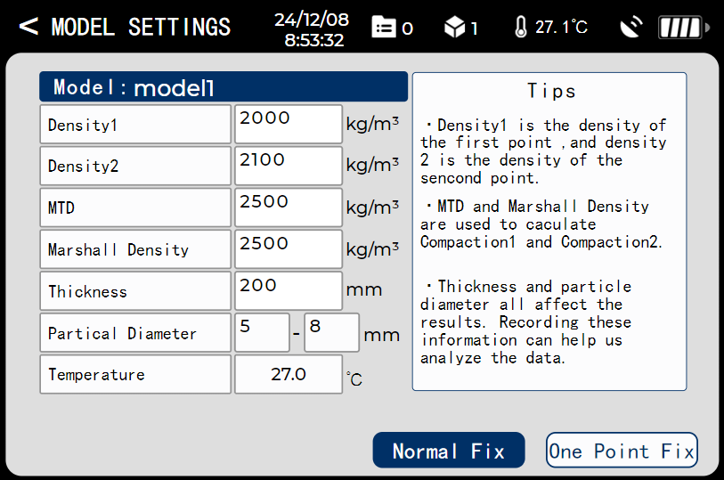
Density1, Density2, MTD and Marshall Density are necessary to be entered. Density1 is the density of the first point, and Density2 is the density of the second point. MTD and Marshall Density are used to caculate Compaction1 and Compaction2.

2.3.3 Normal Fix
In the MODEL SETTINGS menu, click the button “Normal Fix”, then you can enter the menu “NORMAL FIX”.
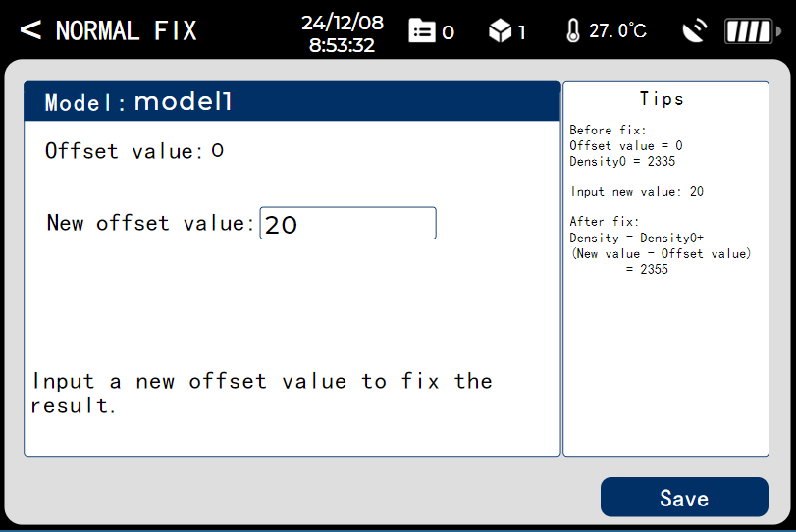
In this menu, you can fix the test result of the project which is associated with the current model by inputting a new offset value.

2.3.4 One Point Fix
In the MODEL SETTINGS menu, click the button “One Point Fix”, then you can enter the menu “ONE POINT FIX”.
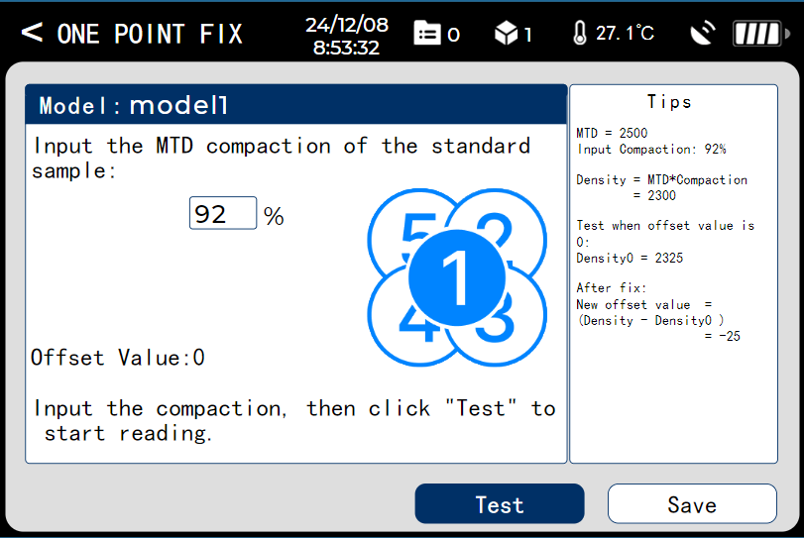
Input the MTD compaction and read the sensor data of the standard sample. Process of the reading is same to the two points calibration.

2.3.5 Delete a model
In the MODEL menu, you can delete a model which is selected by clicking the button "Delete".

2.4 Project
In the EDG START menu, press the button “Project”, turn to the PROJECT menu.

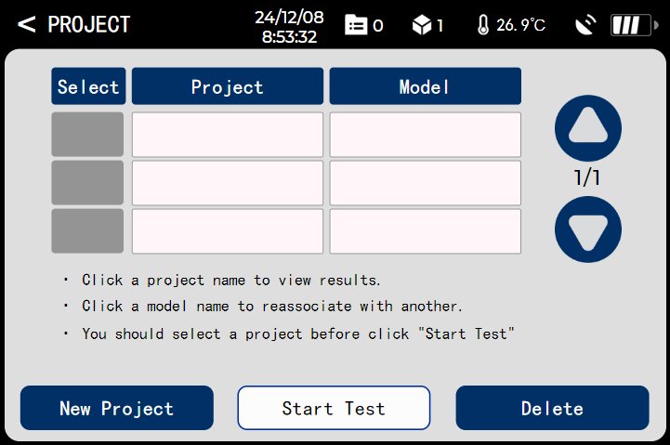

2.4.1 New Project
In the PROJECT menu, you can create a project by clicking the button “New Project”.
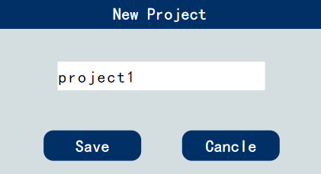
Input a name of the new project, then click “Save”. You can see as follows:

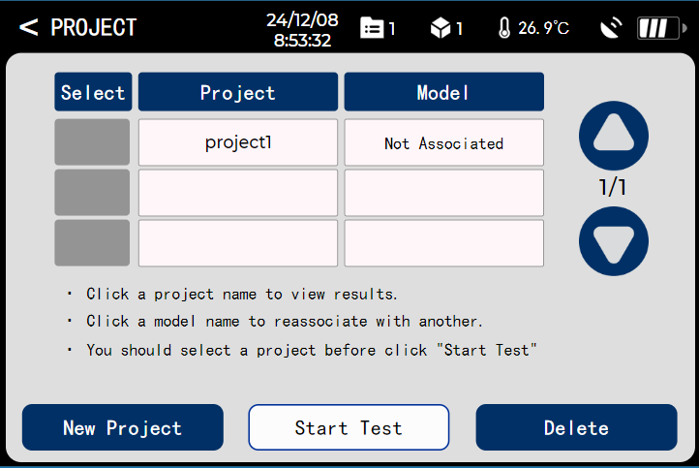
Note: Up to 200 projects can be saved.

2.4.2 Associate with a model
A new project is not associated with any model. Click "Not Associated" area, it shows as follows:
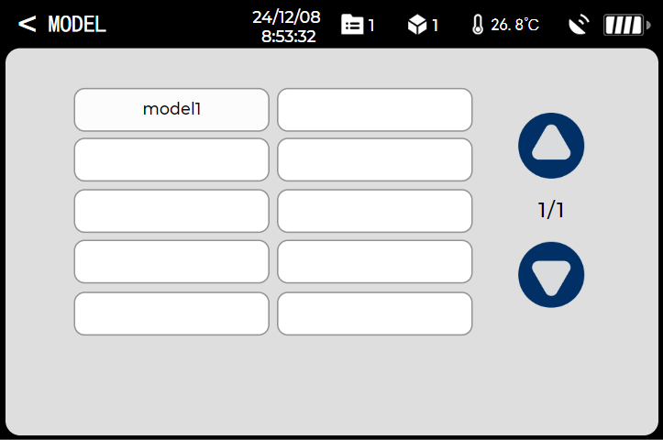
Click the button "model1", it will be associated with the current project.
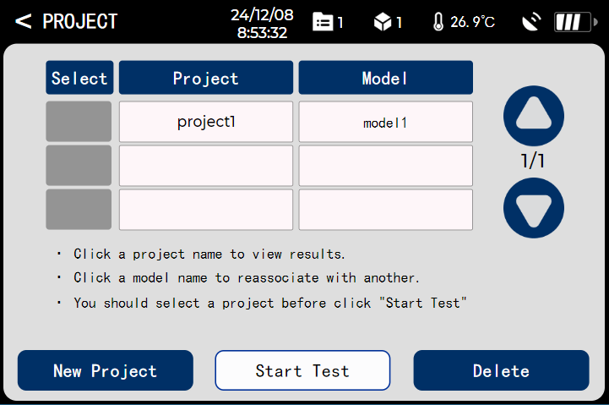

2.4.3 Start Test
Select a project, and click the button "Start Test", test menu will be show:
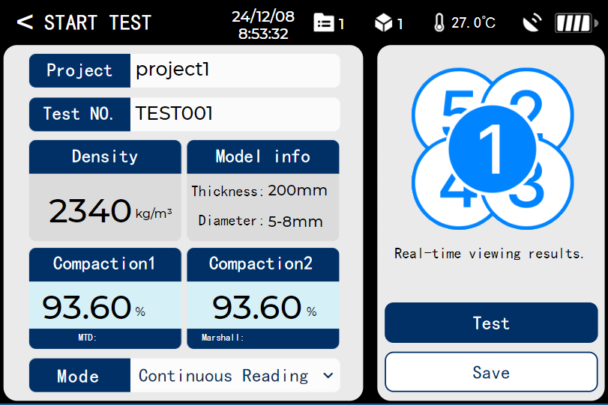
EDG can be used in three different measurement or run modes, respectively:
Continuous Reading Mode
Single Reading Mode
Enhancement Mode
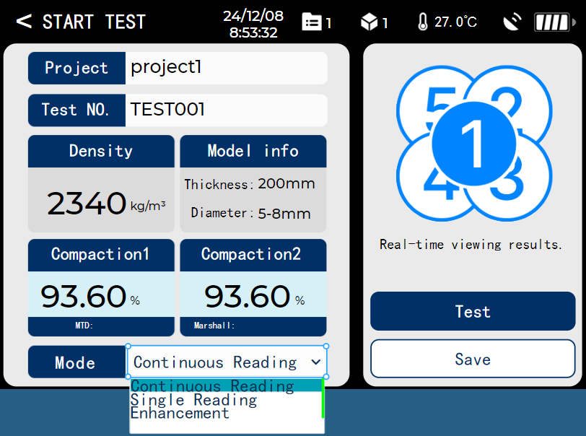
Continuous Reading Mode: Continuous reading mode is used to provide instantaneous density measurements for quality control purposes. When in continuous mode, EDG will display a screen and update values of density, temperature and compaction continuously.
Note: The data cannot be saved in this mode.
Single Reading Mode: single reading mode is used to provide density measurement for one specific point, and conduct single reading each time.
In the mode, click “Test” to start a reading. The unit begins to read and display data from the probe four seconds later after pressing “Test”.
Note: Any touch to the unit by hand or other metal objects is prohibited once the countdown of reading begins, otherwise will distort the reading seriously.
The data gained can be stored on internal data logger. Once a single reading is completed, press "Save" to save measured data.
Note: the unit allows maximum storage of data for 40000 points. You will be prompted to delete data, if exceed this number.
Enhancement Mode:
As shown below:


Draw a circle around the sensor’s outer edge of EDG and take readings in the center (1) and at 2 o'clock, 5 o'clock, 8 o'clock and 11 o’clock positions. After reading number 5 is complete, calculate the average of the 5 readings. Press "Save" to save the data after the measurement is completed.

2.4.4 Result View
In the PROJECT menu, click the project name. You will enter the menu which you can view results and delete test points.
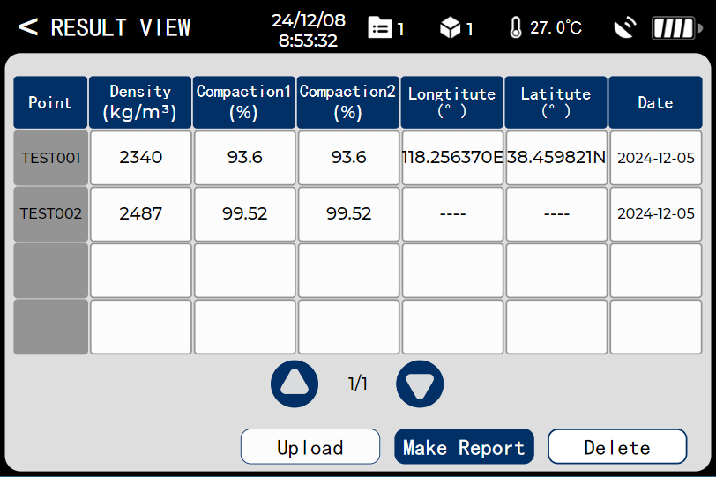

2.4.5 Delete test points of a project
Click the test number “TEST001”, then it is selected and it changed to 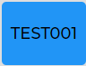. You can delete one test point by clicking the button “Delete” when it is selected.

2.4.6 Export the data
In the RESULT VIEW menu, you can convert the data into an Excel file named for this project by clicking “Make Report”. After the EDG is connected to your computer by a USB cable, you can find a new disk. The report is in the EXCEL folder on the new disk. Then you can check it on your computer.

2.4.7 Delete a project
In the PROJECT menu, you can delete one project which is selected by clicking the button "Delete".
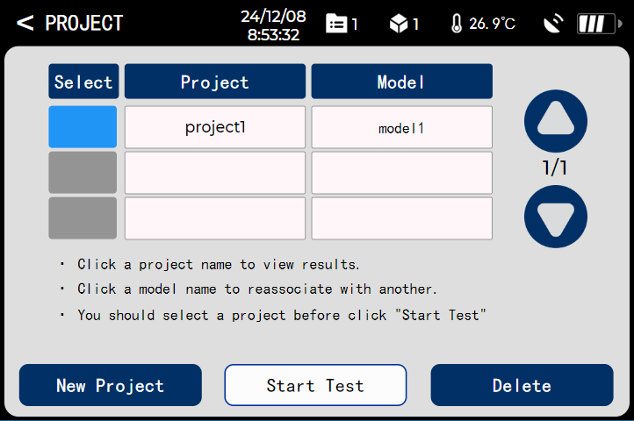

2.5 GPS Control
In the MAIN MENU, you can turn on/off the GPS by clicking the button “GPS CONTROL”.
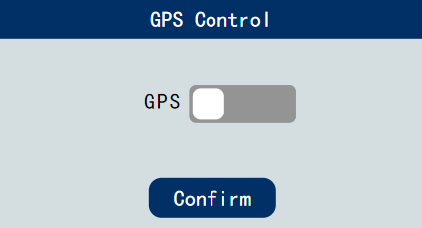

2.6 Data share
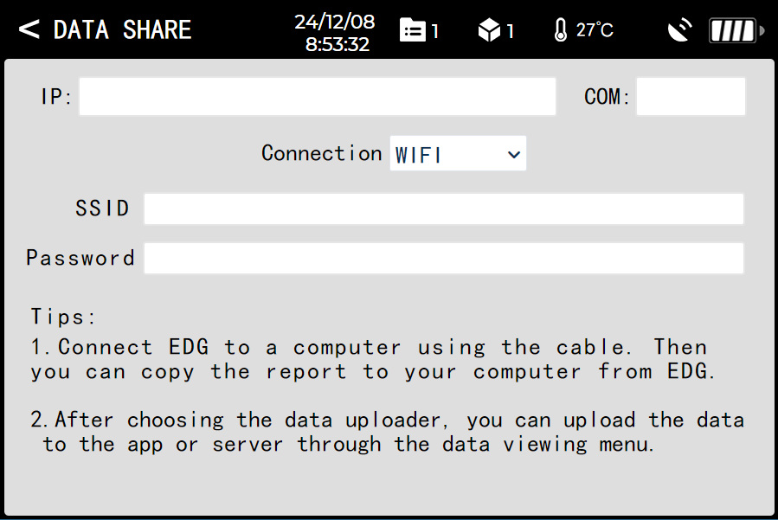
In the menu “DATA SHARE”, you can input the IP and COM of the server. Then you should select a connection method. You need enter the SSID and password when you chose the WIFI method. Then you can send the test results to the server by clicking the button “Upload” in the menu “RESULT VIEW”.

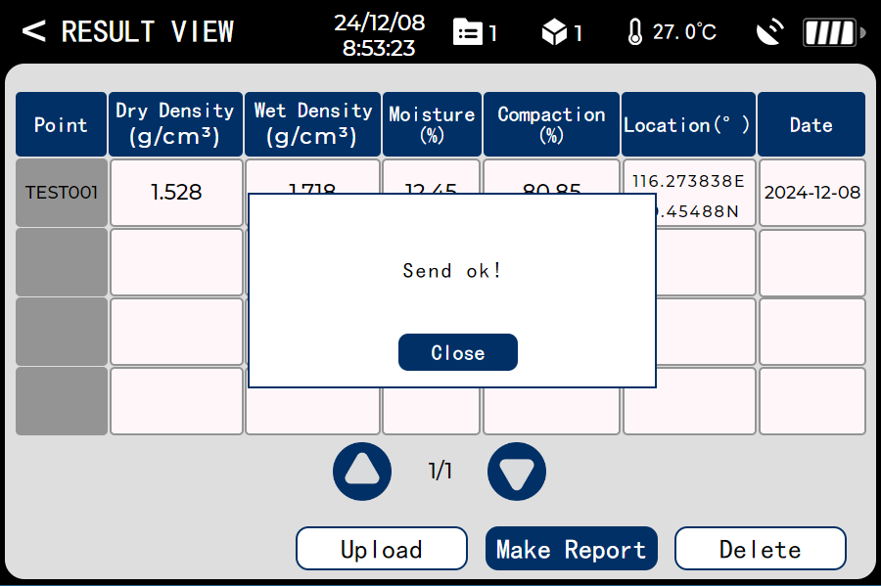

2.7 System Settings
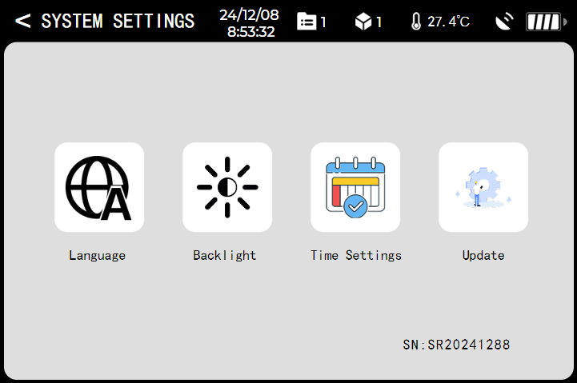

In this menu, you can set language、time and backlight. In addition, you can also check for the firmware updates.

Notice(Routine Operations)
1).Once calibrated the EDG is ready to be used at each job site and asphalt mix. It is suggested that 5 readings be taken at each site following the average reading pattern.
2).Keep EDG bottom surface clean and dry. For accurate readings, the EDG should have a clean, dry and smooth interface with the mat. Therefore, you should wipe the EDG probe surface dry and clean after each reading.
3).Before placing the EDG on the mat, you should check the surface of the mat to make sure there is no loose material on the surface. If a buildup of asphalt begins to form on the probe surface, clean the surface with WD-40.
4).Choose a flat measuring point. While the EDG contains moisture correction algorithms, the most accurate readings will be obtained if areas with low moisture levels are measured. If a measurement area has noticeable surface moisture, you should either wait for the moisture to evaporate or remove the moisture with an absorbent cloth.

Watch for suspicious readings
If a reading seems unusual or suspicious, check for possible measurement errors (dirty surface, wet surface, low battery voltage) and retake the reading.
Rest results are obtained when moisture levels for a series of readings are kept relatively constant. If the moisture level for a reading is more than a percentage point higher or lower than the previous readings, the reading should be treated as suspicious.
Don't touch the EDG while it is making a measurement. Touching any part of the EDG while it is performing a measurement can distort the reading.

